**When Valid HSP login :**  
  
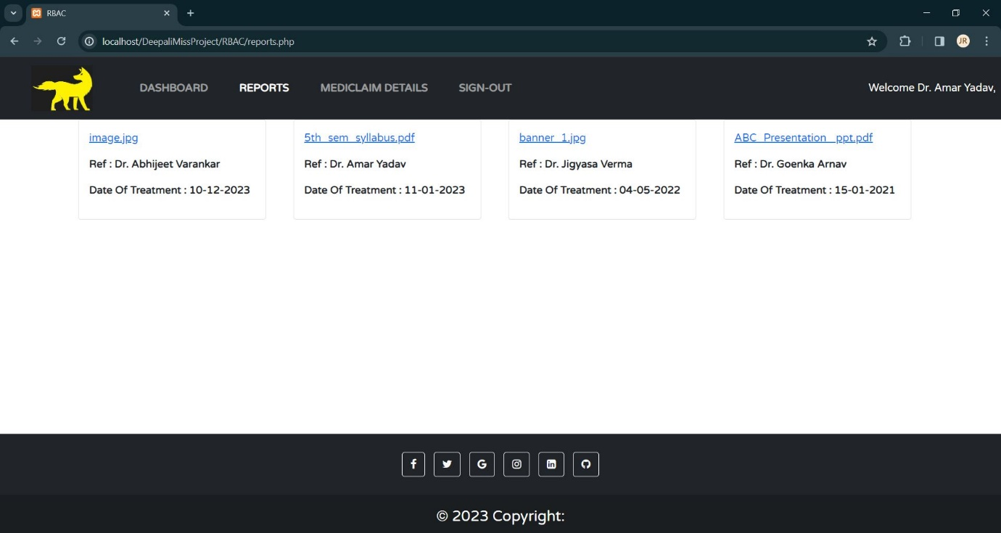

**Summary:** whenever any valid HSP logs-in, in the above case we have logged in as the Doctor. It will show all the reports to which that admin has given rights to doctor.

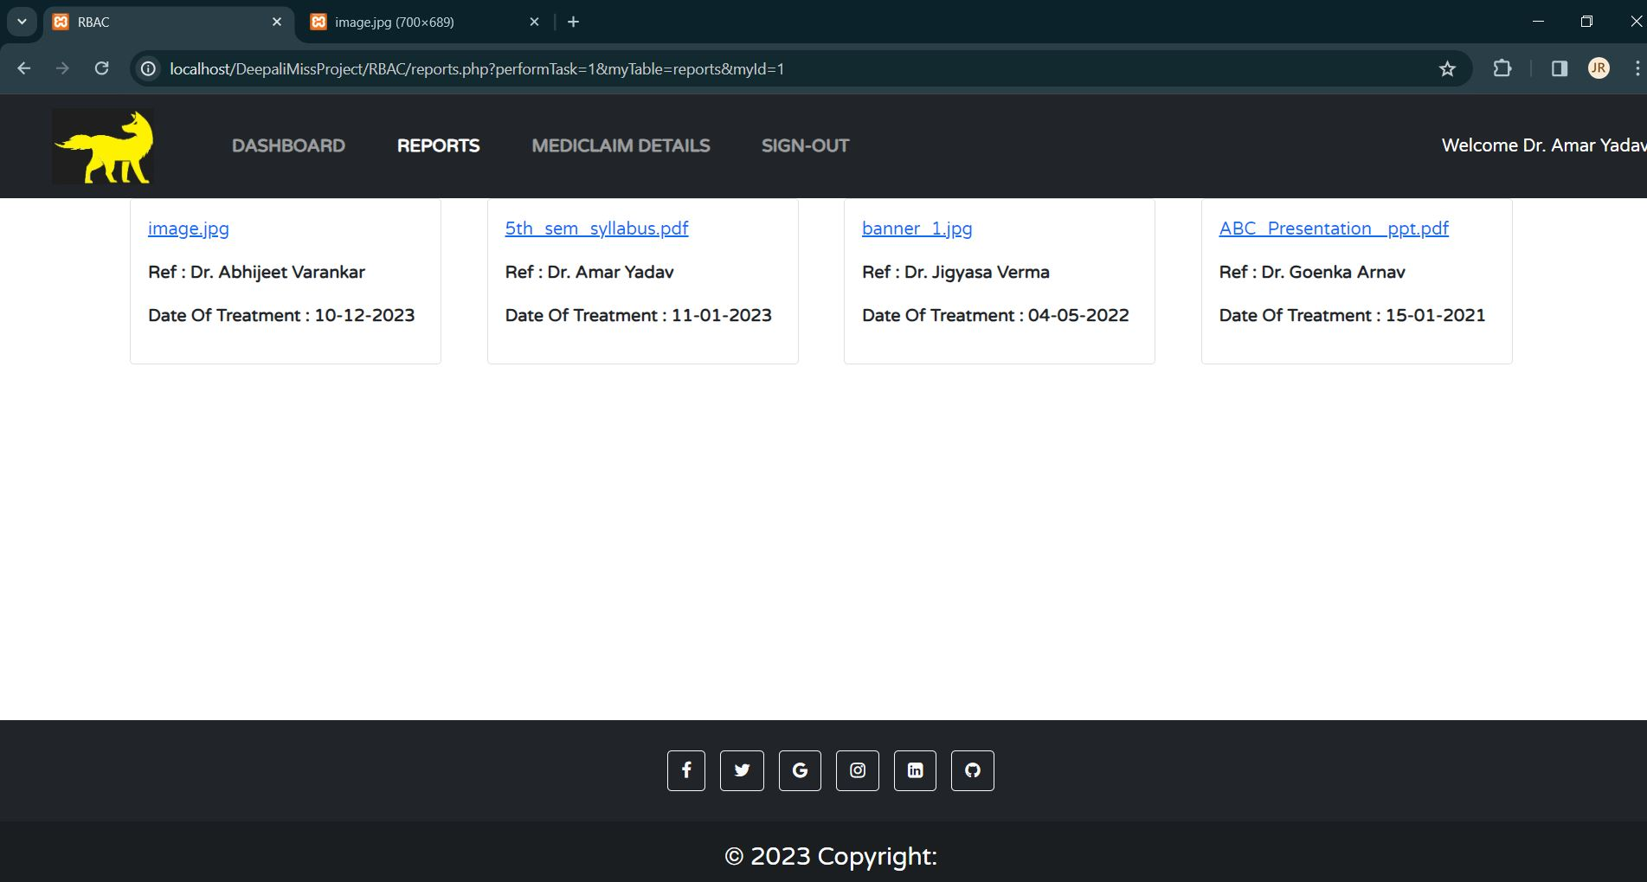

**Summary:**  As the HSP tries to access any of the document, like the above that document will be opened on the new tab. But before letting user to access the document; the system will first check for the **tf** attribute and **rbac+tf** attribute. If both is true then only the HSP will be able to access/ view the document.

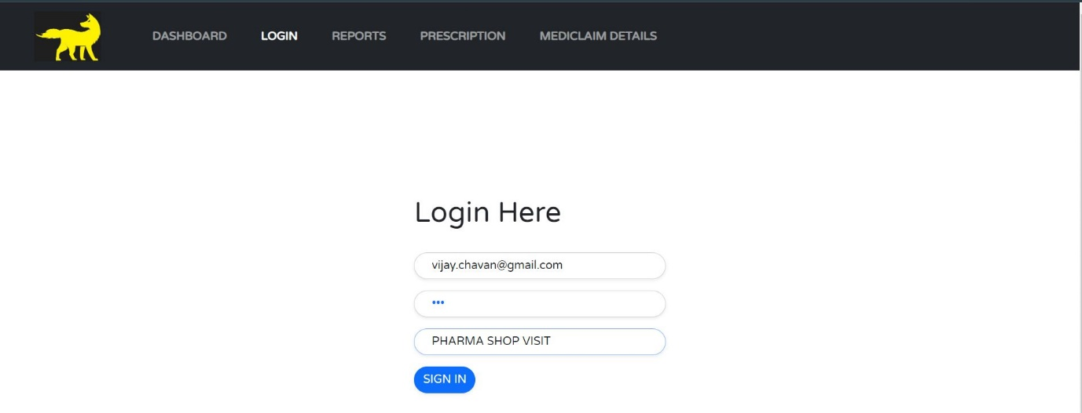

**Summary:** The above is the login page of the system, where now we are trying to logging in as pharmacist.

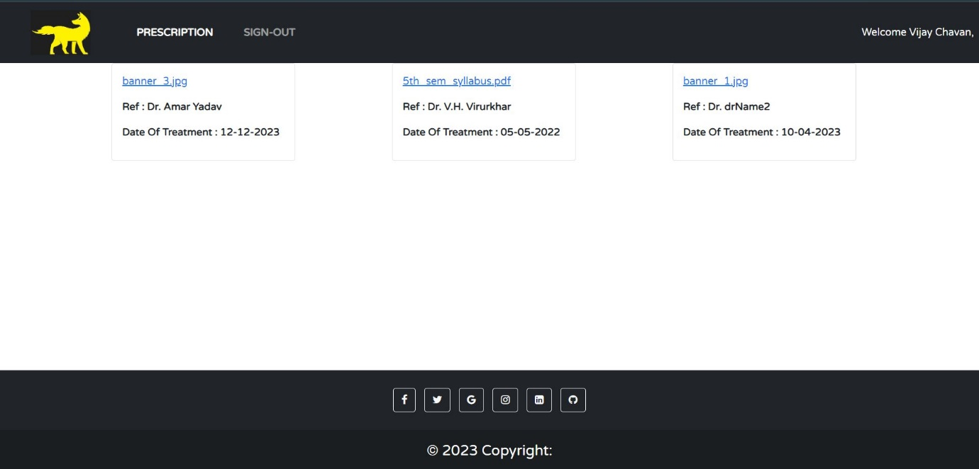

**Summary:** After successful login. The pharmacist will be able to view all the prescription document to which the admin has given rights.

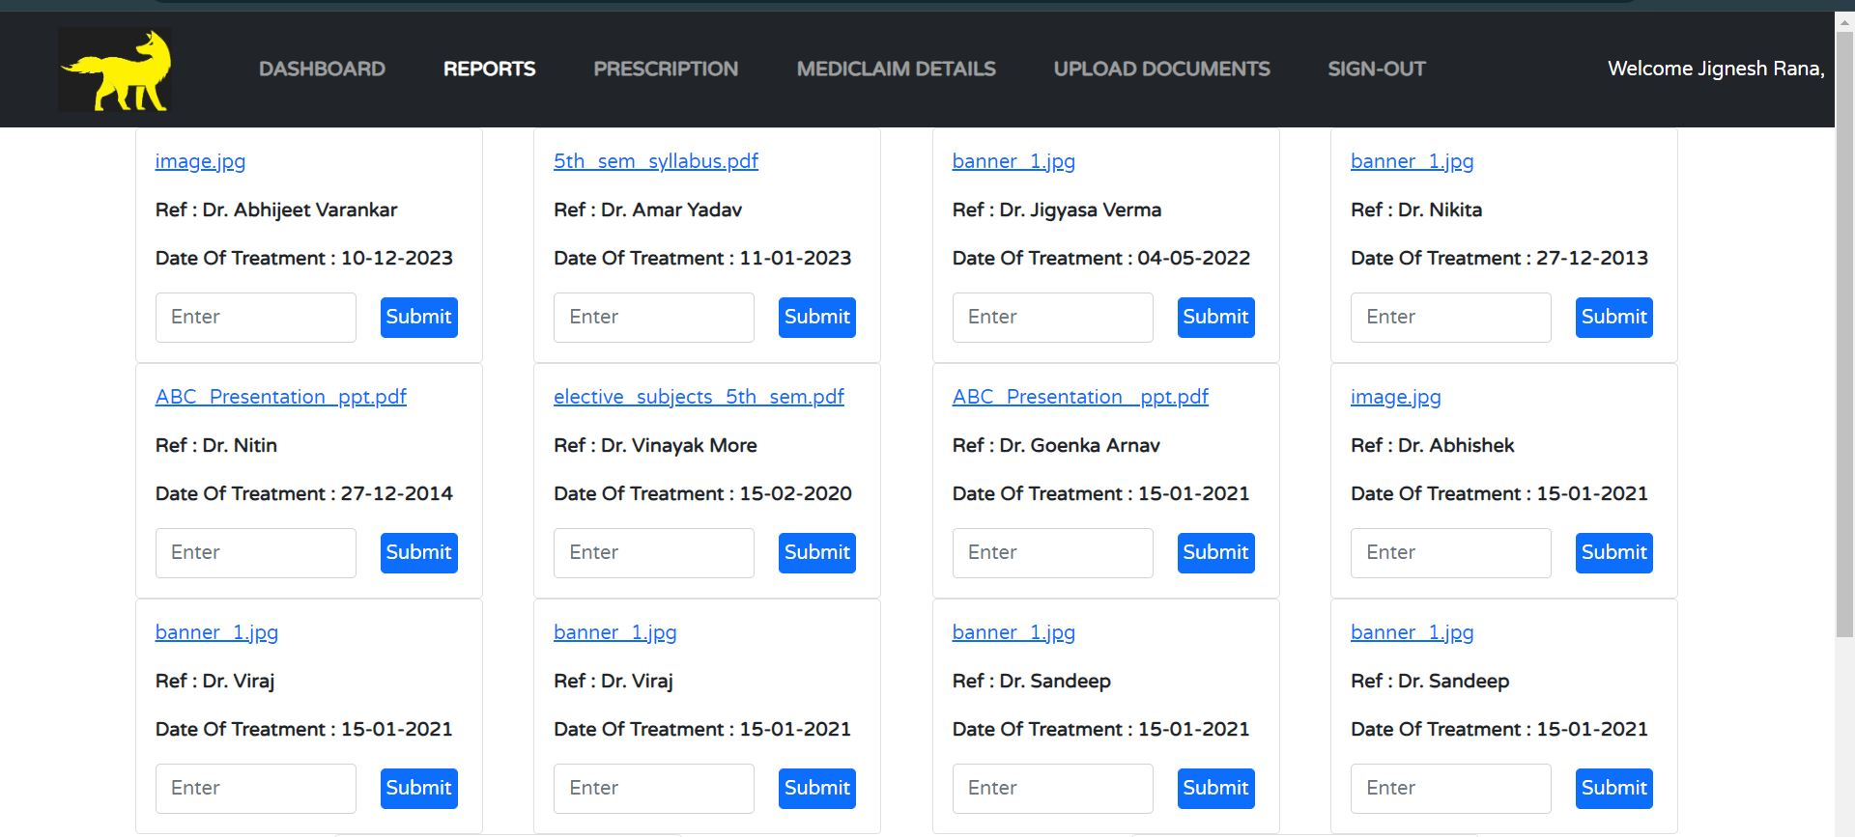

**Summary:** The above is the interface for the admin. Over here in the input, admin have to mentioned the name of the HSP to which he/she want to give rights to access the document.Based on that input, that document will be visible to that HSP portal.

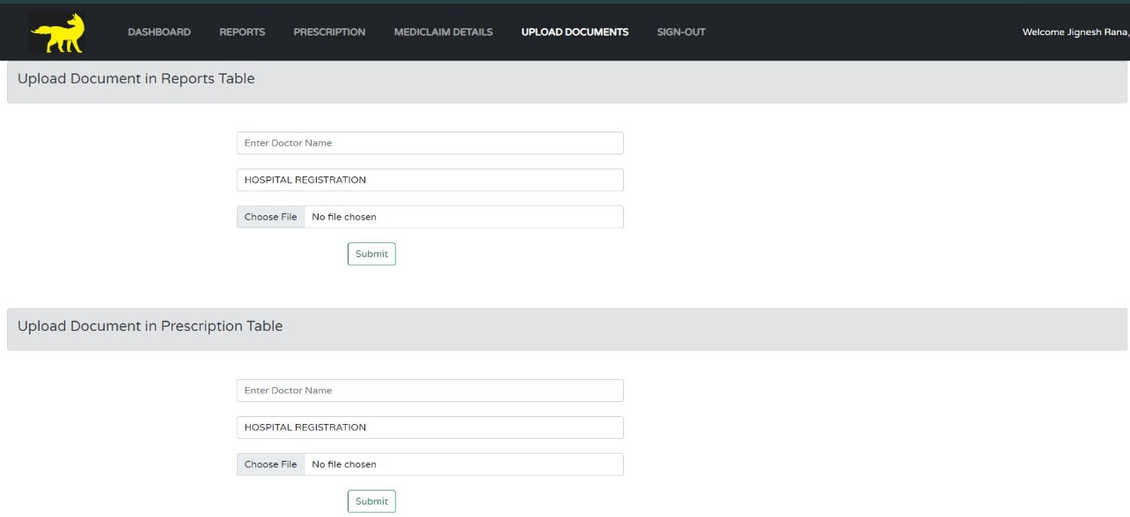

**Summary:** Using above interface, admin will be able to uploads all its document/reports.

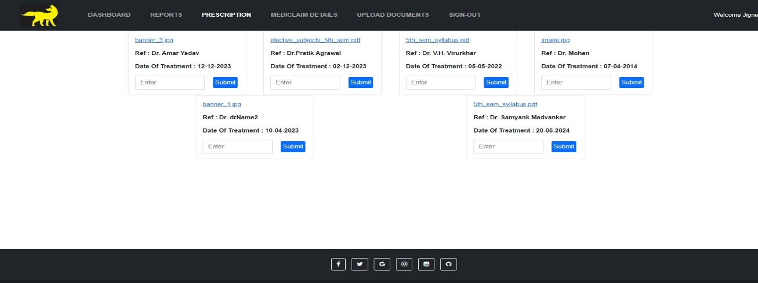

**Summary:** For prescription also, we have same interface as reports.

**Database ScreenShots:**

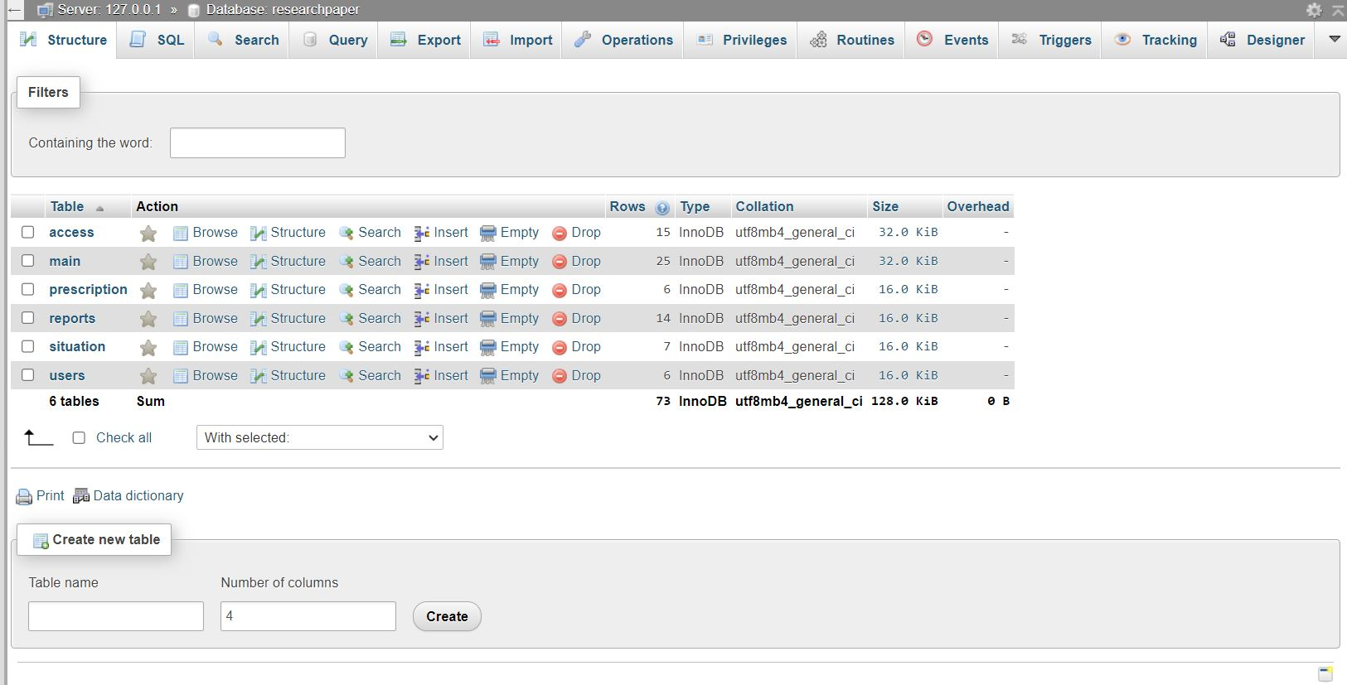

**Summary:** Number of tables available in the database.

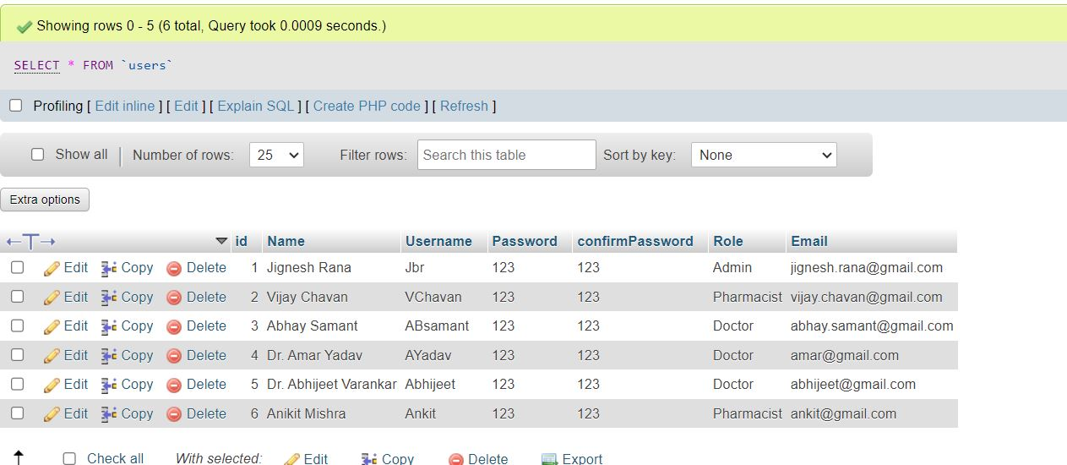

**Summary:** The above is the user table which stores all the user details.

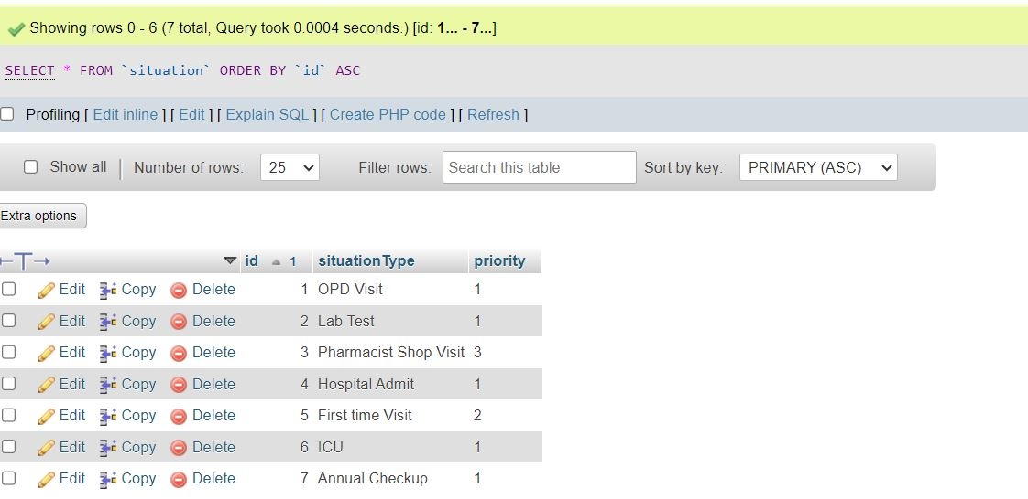

**Summary:** The above is the situation table where we store all the type which is used to calculate the situation Reliability.

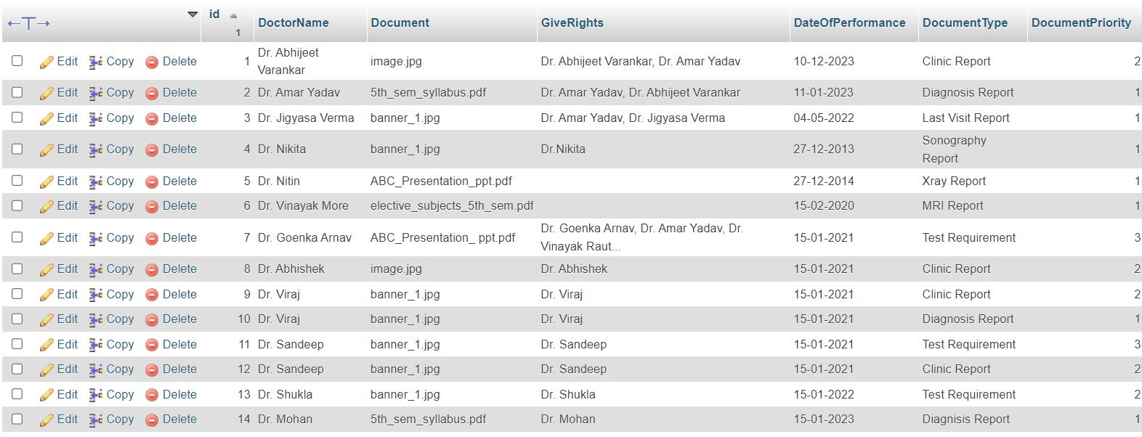

**Summary:** The above is reports table where we store all the documents detail which comes under reports category along with it we manage the attribute name giveRights which stores the name of HSP to whom admin has given rights of that particular document.

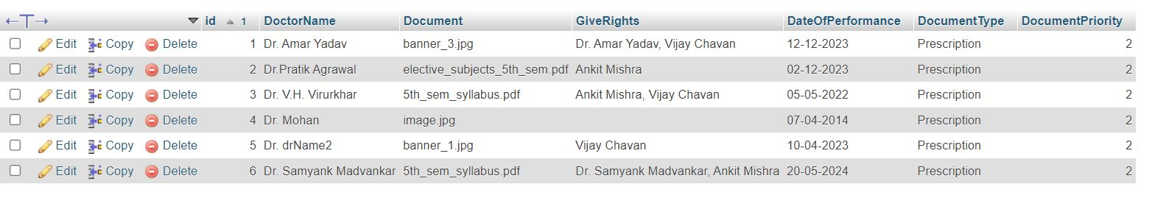

**Summary:** The above is prescription table where we store all the documents detail which comes under prescription category along with it we manage the attribute name give Rights which stores the name of HSP to whom admin has given rights of that particular document.

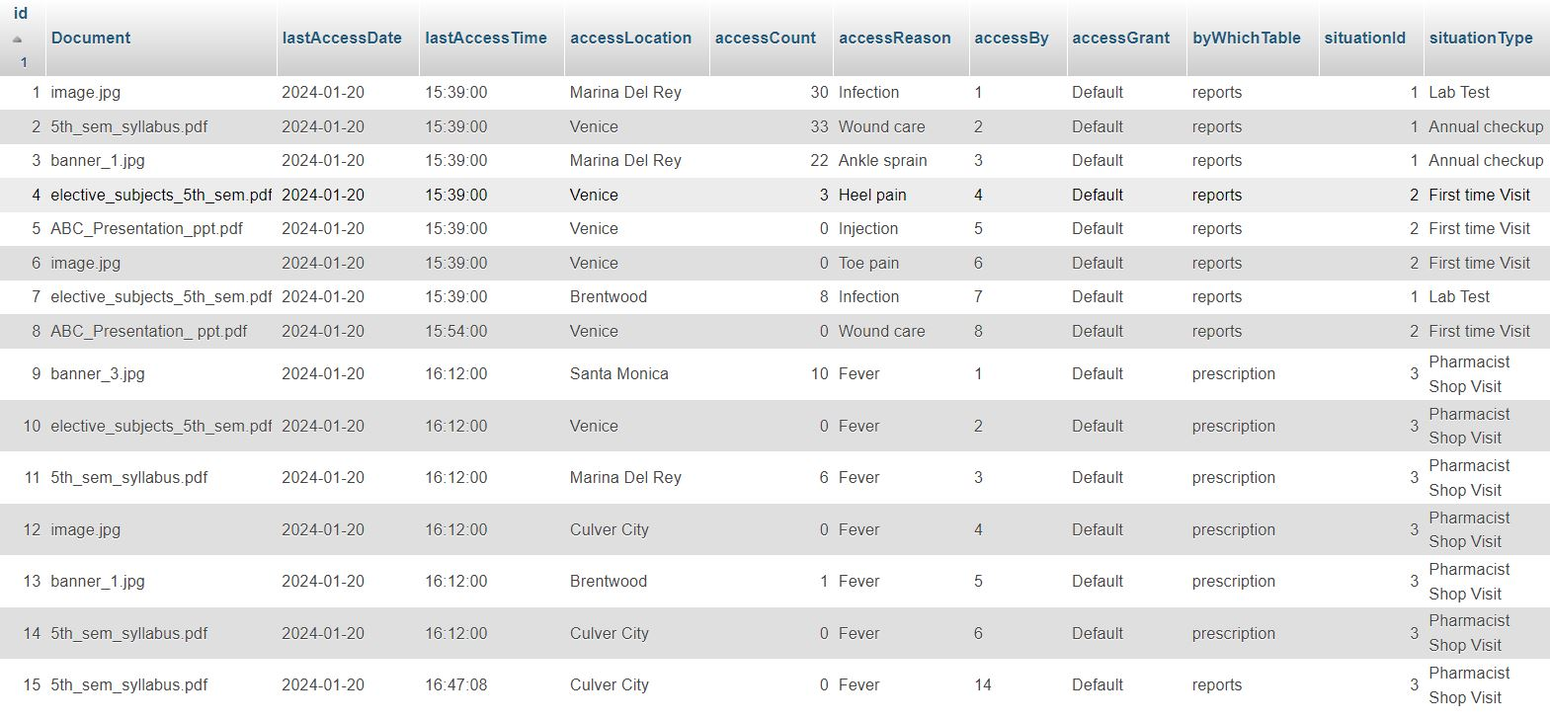

**Summary:** The above is the access table which stores all the record that how many times any document is being accessed and by which category that document belongs and what is the lastAccessDate and lastAccessTime is also being recorded.

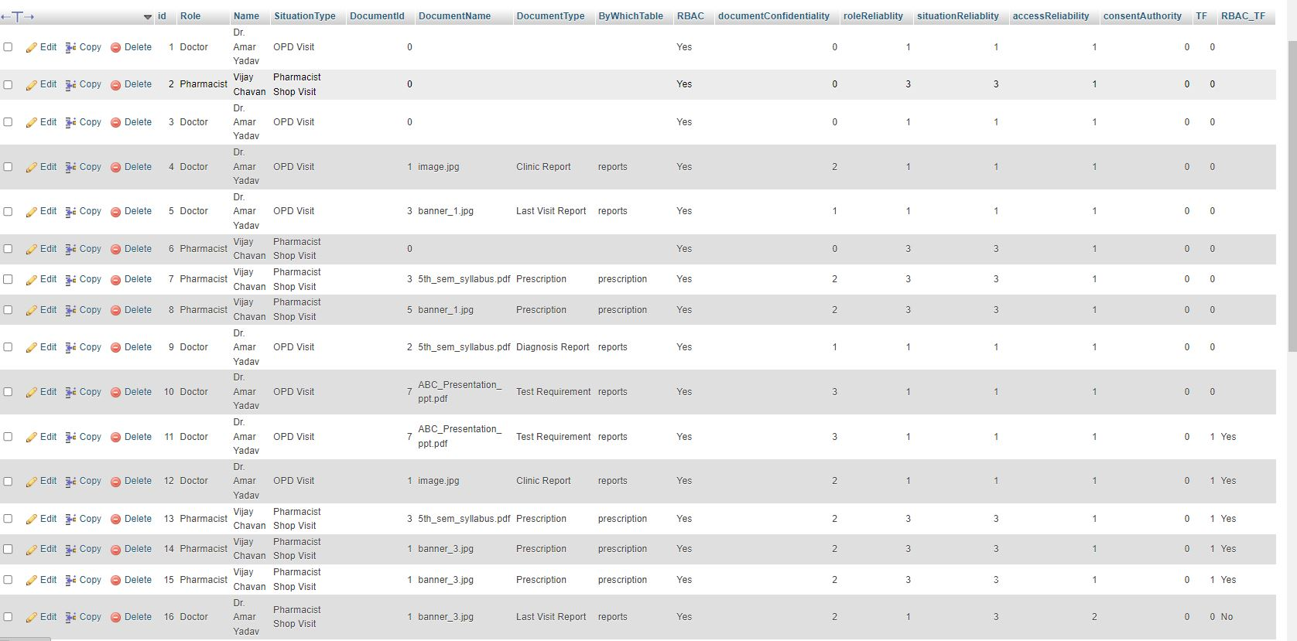

**Summary:** The above is the main table which calculates the tf and rbac+tf which decides that does document should be accessed or not.

**Invalid User**

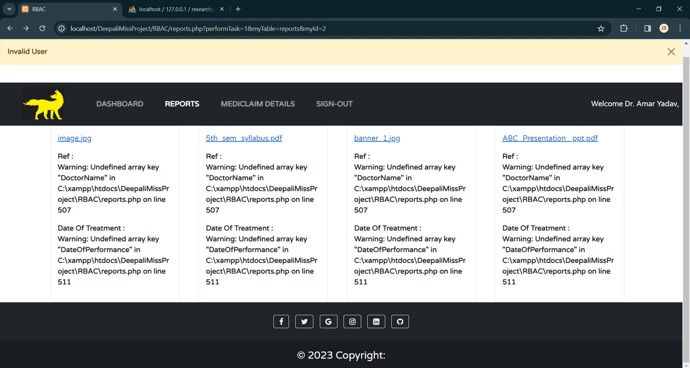

**Summary:** This is the invalid user situation where the role is doctor and situation is pharmacist which is not valid for accessing the documents. Therefore, the above output shows that even though any such invalid user gets the access to the document then also that user will not be able to open the document.

**Summary:**

In this project I have used the HTML and CSS for the frontend to make our project look user interactive and user friendly. In this I have used BOOTSTRAP framework to achieve responsiveness. For backend I have used PHP which helps to achieve validation and verification for the user and it also used to access document and with the help of PHP only I was able to give rights to HSP whether he/she should be able to view the document or not. For the database I have used MYSQL which is a relational database, which requires XAMPP server too. XAMPP is the Server Control panel which provides GUI for MYSQL DATABASE.

All these languages are very well linked with each other hence I decided to use all these languages to implement my project. BOOTSTRAP provides a good CSS styling with its inbuilt classes. PHP backend language provides direct use of backend code in same file in which we have written our code for frontend, which gives good interaction between frontend and backend. MYSQL is used because PHP supports MYSQL well using PHPMYADMIN.